# Lab: Installing the pub1 Database

## Lab Overview

### Scenario

Before you can create and manage the database that will be the focus of the labs in this course, you need to set up your course lab environment. This includes installing MySQL Server and MySQL Workbench and importing the pub1 database.

### Objective

In this lab, you will:

* Import the pub1 database

## Estimated Completion Time

30 minutes

Helpful Hints

If you need more space to work in the MySQL Workbench, there are a few options:

1. You may toggle the instructions with the - in the upper-right corner.
2. Toggle Fullscreen view with the X icon in the upper-right corner.
3. Use your browser's zoom-out feature. Zoom out: [CTRL-minus] or [CMD-minus]; Zoom-in: [CTRL-plus] or [CMD-plus].

If you need to reset your database and/or discard your changes, click the mysql button above, then Reset DB.

## Exercise 1: Import the pub1 Database

Complete the following steps to import the pub1 database.

1. If the lab doesn't start automatically, please click "Start Lab" to launch the MySQL Workbench application manually.
2. Click the pre-configured MySQL connection labeled Vocareum MySQL to link MySQL Workbench to your MySQL server.

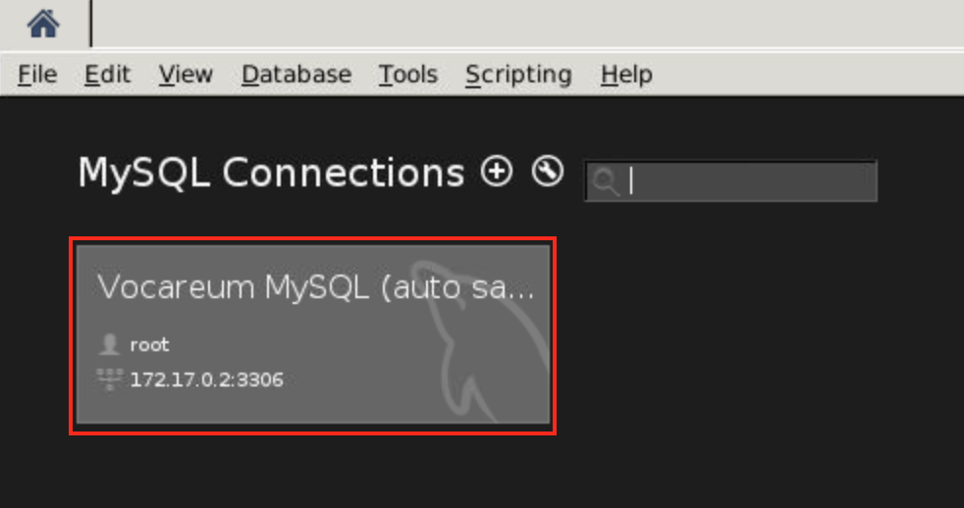

1. Select Continue Anyway on Connection Warning pop-up

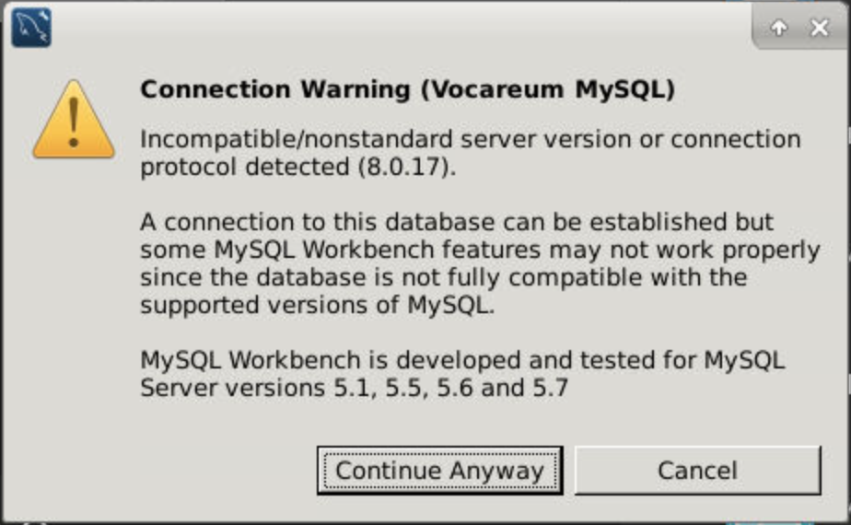

Import the pub1 database.  
4.1. Select Server→Data Import.  
4.2. In the Administration - Data Import/Restore pane, select the Import from Self-Contained File radio button.  
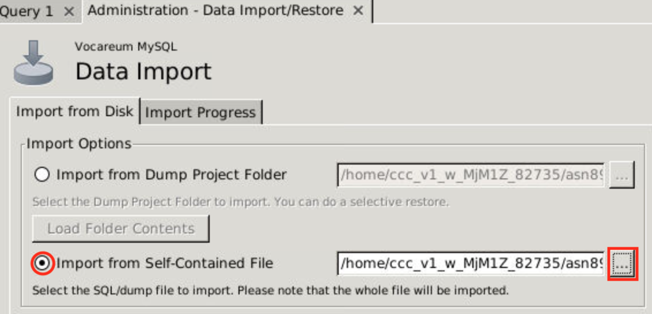  
4.3. Change the import path to: work / pub1.sql  
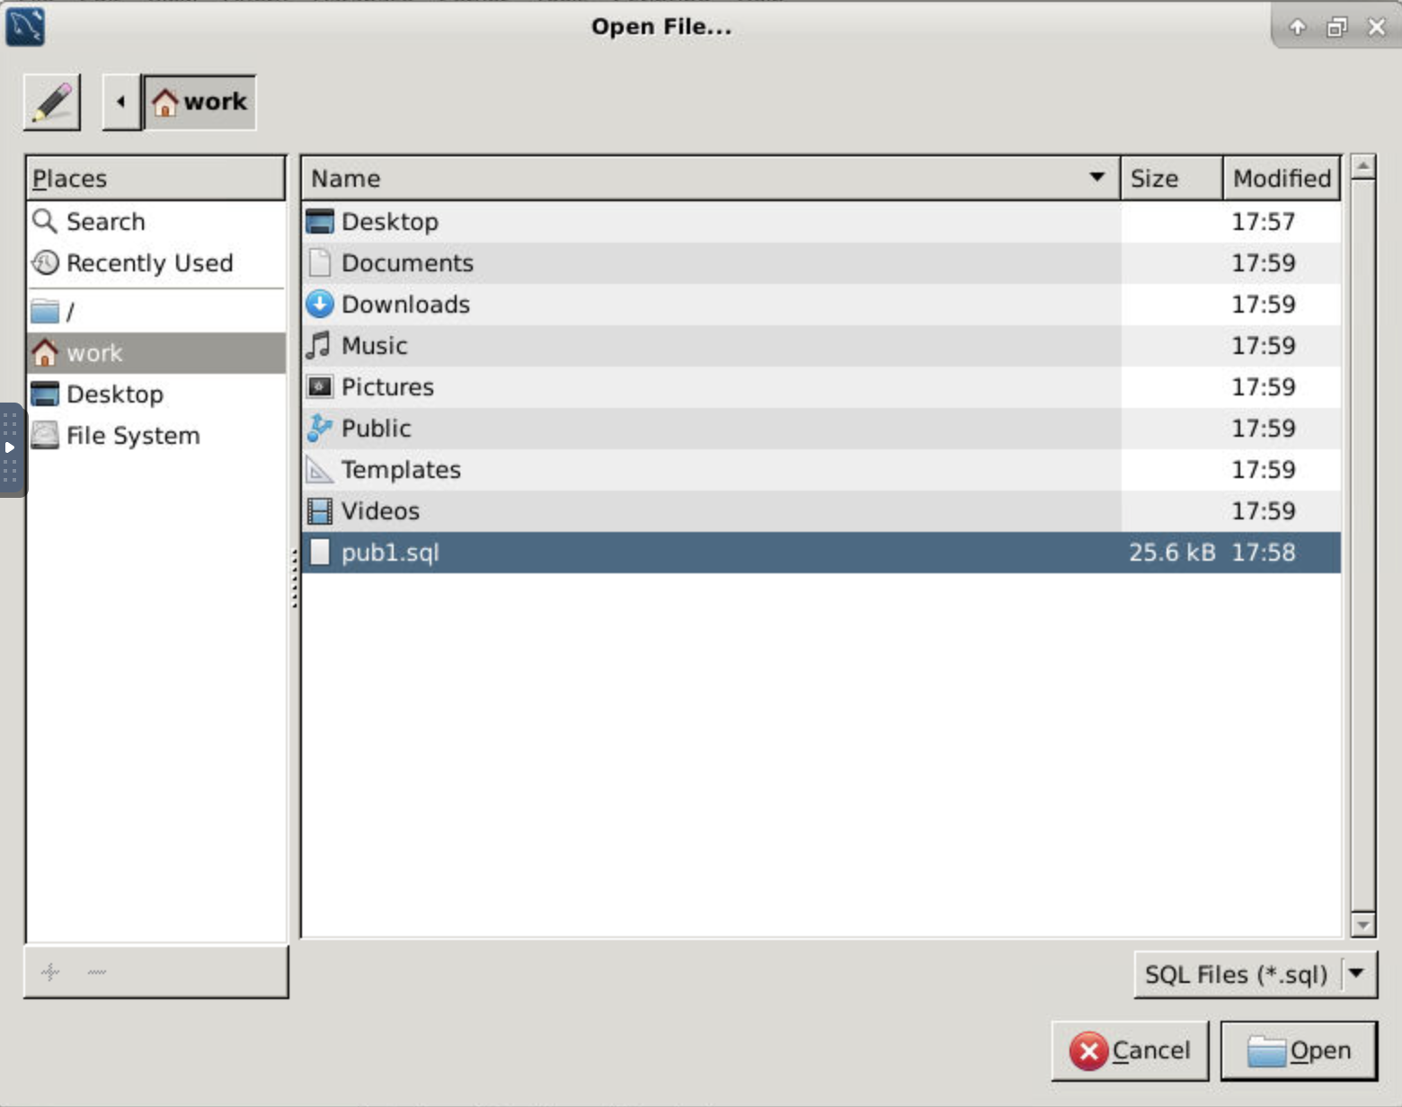  
4.4. Next to the Default Target Schema drop-down list, select New.  
4.5. In the Create Schema dialog box, in the Name of schema to create text box, type pub1 and select OK.

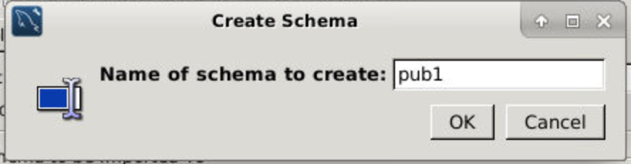

4.6. Select Start Import.  
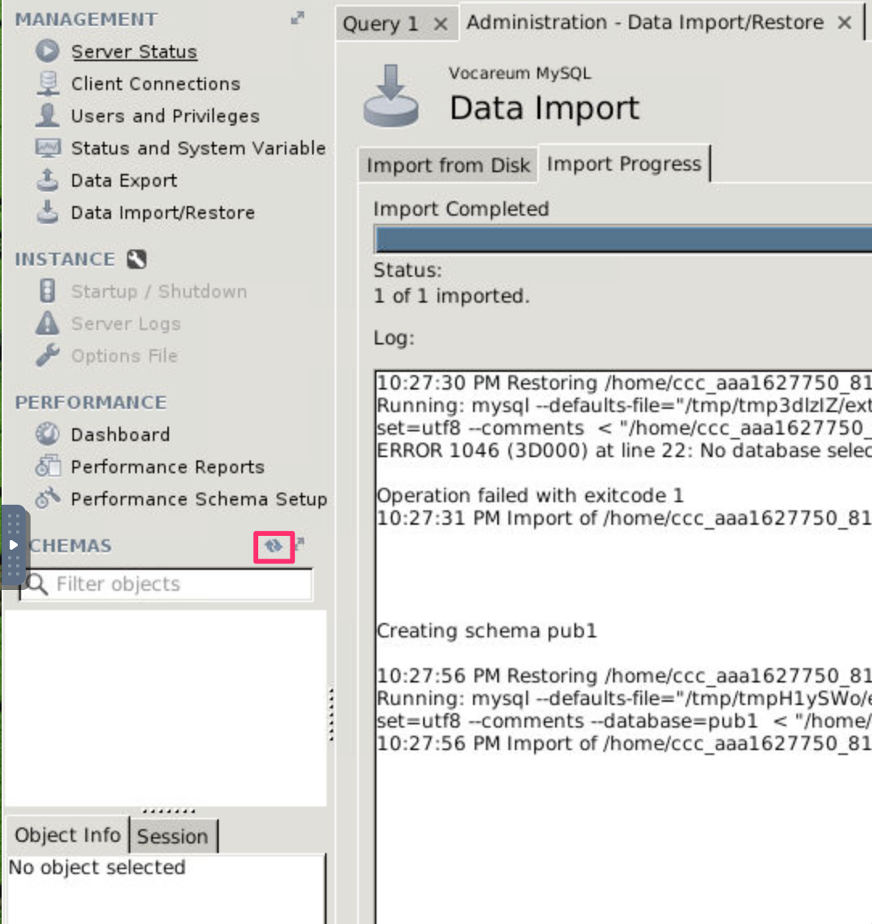

Verify that the import was successful.  
5.1. In the navigation pane, go the Schemas tab.  
5.2. Left-click on Refresh button.  
5.3. Expand pub1→Tables and verify that there are six tables.  
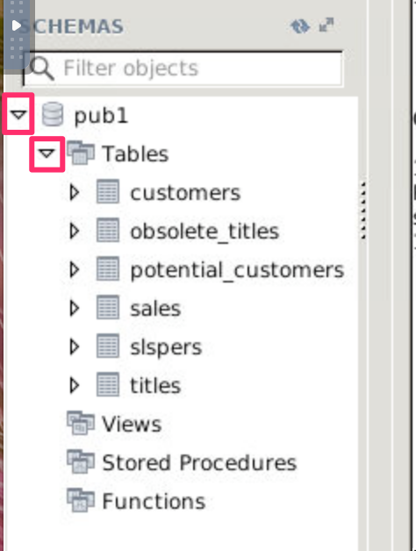

## STOP